Form 223

The following instructions may please be noted before filling the return
- Please use the correct return form. This return form is for VAT dealers who are also in the business of executing works contracts, leasing and dealers opting for composition only for part of the activity of the business.

- Other return forms are as follows:

Form No. | To Be Used By
221 | All VAT dealers other than dealers executing works contract, dealers engaged in leasing business,
 | composition dealers (including dealers opting for composition only for part of the activity of the
 | business), PSI dealers and notified Oil Companies.
222 | All composition dealers whose entire turnover is under composition (excluding works contractors
 | opting for composition and dealers opting for composition only for part of the activity of the
 | business).
224 | PSI dealers holding Entitlement Certificate. (Transactions by PSI dealers relating to the business
 | of execution of works contracts, leasing, trading and composition only for part of the activity of
 | the business to be included in a separate return in Form 223).
225 | Notified Oil Companies. (Transactions by Oil companies relating to the business of execution of
 | works contracts, leasing and composition only for part of the activity of the business to be
 | included in a separate return in Form 223).

- ‘Fresh return’ is the return which is filed in compliance of defect notice in Form 212 and ‘revised return’ u/s 20(4) of MVATA, 2002 is the return in substitution of the original return filed earlier. Balance payable as per Revised

/ Fresh return, if any, to be paid separately by Challan in Form 210 and the Fresh return / Revised return along with a self attested true copy of the receipted challan to be filed with the Sales Tax Office.

- MVAT and CST RC number should be exactly as per the Registration Certificate issued to you. RC Number issued under the BST Act and the CST Act, with Alpha ‘B’ and ‘C’, respectively, continues to be valid. Alpha ‘V’ is to be used only if RC has been issued on or after 01.04.2005 in Form 102.

- Please fill in all the columns. If no information is required to be given, please indicate ‘NIL’ or ‘Not Applicable’.

- Please provide the information in the appropriate box. In ‘Rate of Tax’ column, extra rows have been provided for incorporating the rates not specified in the Form. Strikethrough of the rates specified should be done only if extra rows provided are not sufficient. If need be, you may please add extra rows.

- All the figures to be rounded off to the nearest rupee.

- Please ensure that return is signed by the Authorised Signatory and the name and designation of the Signatory is indicated.

- The following are the detailed instructions for filling in information in each of the boxes –

Box | Particulars
No.
5 | Composition schemes are for Retailers, Restaurants/Clubs/Caterers, Bakers and Second-hand car
 | dealers. Works contractor opting to pay tax under composition option to indicate so in the first box
6(a) | In respect of sales other than sales under composition schemes for Retailers, Restaurants/Caterers,
 | Bakers and Second-hand car dealers, gross receipts on account of sales to include tax, whether
 | recovered separately or included in sale price. Value of branch / consignment transfers to include
 | branch transfers within the State also. Retailers, Restaurants/Caterers, Bakers and Second-hand car
 | dealers opting for composition are not entitled to recover composition amount
6(b) | Gross receipts on account of sales under composition schemes other than works contracts under
 | composition option
6(c ) | Gross receipts including sales (excluding taxes) on account of on-going contracts where tax
 | liability has been discharged as per provisions of the ‘Earlier Law’. (On-going works contracts
 | means contracts entered into prior to 01.04.2005 and the execution of the said contract has been
 | continued after 01.04.2005)
6(d) | Gross receipts including sales (excluding taxes) on account of on-going leasing contracts where
 | tax liability has been discharged as per provisions of the ‘Earlier Law’. (On-going leasing contract
 | means contracts where the transfer of right to use goods has been effected prior to 01.04.2005 and
 | where sale price is due and payable after 01.04.2005)

 | Value of branch transfers within the State to be shown only if you are filing separate returns for the
6(h) | place of business from where stock transfers are effected and the place of business to which the goods
 | are dispatched on stock transfer basis
6(i) | Deduction u/s 8(1) should be inter-State sales, sales outside the State and sales in the course of import
 | and export falling u/s 3, 4 and 5 of the CST Act and CST amount whether recovered separately or
 | included in sale price. Value of inter-State branch / consignment transfers should also be included
6( j ) | Non-taxable labour and other charges / expenses as provided in Rule 58 for execution of works
 | contract – applicable only if tax is paid under non-composition option
6(k) | Amount paid by way of price for sub-contract – applicable only where the contractor has opted for
 | composition. Value of contract executed by the sub-contractor / principle contractor which is
 | exempted from tax against Form 408 / 409 to be shown in Box 6(m). Similar exemption in
 | respect of on-going contracts to be shown in Part C
6(o) | Other reductions / deductions in the nature of non-taxable charges, such as, labour charges and other
 | allowable reductions, such as, reduction as per Rule 57(2) in respect of resales of goods originally
 | manufactured by an unit under the exemption mode of the Package Scheme of Incentives, value of
 | goods returned and amount of deposit refunded within the prescribed period and the amount of
 | deposit, turnover of second and subsequent sales of Drugs covered by Schedule / Entry C29 on which
 | sales tax has been paid by the first seller
7B(a) | Retailers - Turnover of all sales including sales of tax-free goods during the tax period
7B(b) | Class of goods excluded from the scheme are (1) Foreign liquor, Country liquor and liquor imported in
 | India, (2) Drugs covered by Entry C 29 and (3) Motor Spirits notified under section 41(4)
7B(c ) | Allowable reductions / deductions are -
 | Turnover of purchases including turnover of purchases of tax-free goods and tax paid on
 | purchases
 | Amount of every credit received from any vendor whether or not such credit is in respect of any
 | goods purchased
7C(a) | Restaurants, Clubs, Caterers etc. - Total turnover of sales without any deduction liable to tax
7D(a) | Bakers - Total turnover of sales without any deduction liable to tax
7E(a) | Second hand motor vehicle dealers – Total turnover of sales
7E(b) | Allowable reduction = 85% of total turnover of sales
8(b) | Exempted sales under the ‘Earlier Law’ are-
 | Sales to State Governments
 | Sales to Diplomatic Authorities
 | Sales to SEZ developers or SEZ Units
 | Sales by principal sub-contractor / contractor against Form XXXI / XXXII
8(c ) | Allowable deductions u/s 6 of the ‘Earlier law’ are-
 | Turnover of sales of declared goods purchased from dealers registered under the BST Act or
 | purchase tax (PT) paid goods purchased from un-registered dealers(URD), which are used in the
 | same form without doing anything which amounts to manufacture
8(d) | Allowable deductions u/s 6 (A) of the ‘Earlier law’ are-
 | Goods covered by Schedule A of the BST Act, 1959
 | Goods which are totally and unconditionally exempted under notification u/s 41 of the BST Act,
 | 1959
 | Goods purchased from RD under the BST Act, 1959
 | Goods purchased from URD on which PT has been paid under the BST Act
9(b) | Sales exempted under the ‘Earlier law’ are-
 | Sales to certified SEZ
10 | Total of net turnover of sales should be equal to amount shown in Box No. 6(s)+7(F)+8(f)+9(c )
10A | Sales tax collected in excess of the amount tax payable would be the difference in tax amount shown in
 | 6(g) and total of tax amount shown in Box 10
11(a) | Turnover of purchases should also include value of branch / consignment transfers received and job
 | work charges
11(h) | In addition to other purchases not eligible for set-off, in respect of composition dealers purchases not
 | eligible for set-off would include the following –
 | - In respect of Retailers, Restaurants / Caterers and Bakers – purchases corresponding to any class of
 | goods which are sold or resold or used in packing of goods under the composition scheme
 | - In respect of second -hand motor vehicles dealers – purchases of second-hand motor vehicle which
 | are sold or resold under composition scheme

11(k) | Other allowable deductions include non-taxable charges, such as, labour charges, value of purchases
 | return during the period. Adjustment of set-off on account of purchases return to be shown in 13(j)
12 | Total of tax rate wise analysis of within the State purchases from registered dealer eligible for set-off
 | should be equal to Box 11(m)
13(a) | Purchase value and tax amount should be equal to the amount shown in Box 12
13(b) | Set-off on trading goods held in stock as on 01.04.2005 should be equal to set-off amount claimed in
 | stock declaration filed
13(c ) | Set-off to be claimed only if capital goods held in stock as on April 1, 2005 are sold during the period
13(e) | Tax amount should be equal to 4% or 1% of the purchase price, as the case may be
13(f) | Other reductions under various rules, including set-off on purchases for use in execution of on-going
 | works contracts where tax liability has been discharged as per provisions of the ‘Earlier Law’
13(i) | Adjustment to set-off claimed in earlier return can be on account of supplementary bills or debit notes
 | received from suppliers or on account of variation of the basis adopted for computation of admissible
 | set-off
13(j) | Adjustment to set-off claimed in earlier return can be on account of any of the contingencies given in
 | Rule 53 of MVATR, 2005 including on account of purchases return during the period or on account of
 | variation of the basis adopted for computation of admissible set-off
13(k) | Set-off available to be shown in Box 14A(a)
14A(b) | Excess brought forward should be equal to the amount of excess carried forward in the return for the
 | previous period
14A(c ) | Amount already paid should be supported by tax paid challan. (please do not attach tax paid challans
 | along with the return)
14A(d) | Amount adjusted should be supported by Refund Adjustment Order (please do not attach Refund
 | Adjustment Order along with the return)
14A(e) | Amount adjusted should be supported by WCT TDS Certificates. (Please do not attach WCT TDS
 | Certificates with the return)
14B(b | After adjustment of sales tax payable, excess credit, if any, can be utilized for adjustment of CST /ET
&c) | payable
14B(d) | Applicable only in respect of dealers also filing return in Form 224 / 225. Such dealers should carry
 | forward excess credit or claim refund in return in Form 224 / 225
14C | Net excess credit for the period - you can, in accordance with rules, carry forward excess credit to
 | subsequent period in Box 14C(a) or claim refund in Box 14C(b)
14C(a) | Excess credit to be carried over to subsequent period within the same financial year
14C(b) | Excess credit - Refund can be claimed in each of the return by an exporter effecting sales under section
 | 5(1) / 5(3) of the CST Act, 1956, 100% EOU, STP, SEZ or EHTP Unit and PSI units. Other dealers to
 | claim refund in March return. Refund cannot be carried over to subsequent year
14D(d) | Applicable only in respect of dealers also filing return in Form 224 / 225. Such dealers should pay net
 | balance payable with return in Form 224 / 225
14D(f) | Revised / Fresh return to be filed with the Sales Tax Office along with second copy of the Challan
 | in Form 210

Part – I

FORM 223
( See Rule 17, 18 and 45 )

Return-cum-challan of tax payable by a dealer under M.V.A.T.Act, 2002

(For Tax payment through Treasury / Bank)

 |  |  |  |  |  |  |  |  |  |  |  |  | Please tick whichever is applicable
 | Periodicity of return |  |  |  |  |  |  | Monthly |  |  |  |  |  |  |  |  | Quarterly |  |  |  |  |  |  |  |  |  | Six-monthly
 | Type of return |  |  |  |  |  |  | Original |  |  |  |  |  |  |  |  |  |  | Fresh |  |  |  |  |  |  |  |  |  | Revised
1) |  | M.V.A.T. R.C. No.
2) |  | C.S.T. R.C. |  | No.
3) |  | Period covered by the return
 |  |  |  |  |  | From |  |  |  |  |  |  |  |  |  |  |  |  |  |  |  |  |  | To
 |  | Date |  |  |  | Month |  |  |  | Year |  |  |  |  |  |  | Date |  |  |  |  |  | Month |  |  |  |  |  |  | Year
4) |  | Name and address |  |  | of the dealer
 |  | Name
 |  | Address
 |  |  |  |  |  |  |  |  |  | PIN Code

- Business activities include (Please tick one or more box, as applicable)

 | Execution of | Leasing | Part of the business activity under composition option (Please tick one or more box, as
 | works contracts, | business | applicable)
 | including under |  | Retailer | Restaurant , Club, | Baker | Second hand
 | composition |  |  | Caterer etc. |  | motor vehicles
 | option |  |  |  |  | dealer

- Computation of net turnover of sales liable to tax: (Part A)

 | Particulars | Amount (Rs.)
a) | Gross receipts including sales, taxes, value of branch / consignment transfers
 | and job work charges
 | Less:
b) | Turnover of sales under composition scheme(s), other than works contracts
 | under composition option (Computation of turnover of sales liable to tax to
 | be shown in Part B)
c) | Turnover of sales (excluding taxes) relating to on-going works contracts
 | (Computation of turnover of sales liable to tax to be shown in Part C)
d) | Turnover of sales (excluding taxes) relating to on-going leasing contracts
 | (Computation of turnover of sales liable to tax to be shown in Part D)
e) | Total deductions (b+c+d)
f) | Balance: Gross receipts including sales, taxes, value of branch / consignment
 | transfers and job works charges (a-e)

 | Less:
g) | Tax amount included in sales in Box (f) above, whether shown separately or
 | otherwise
h) | Value of branch / consignment transfers within the State
i) | Sales u/s 8(1) including taxes and value of branch / consignment transfers
 | outside the State
 | Turnover of sales u/s 5 of the CST |  | Amount (Rs.)
 | Act included in Box 6 (i)
j) | Non-taxable labour and other charges / expenses for execution of works
 | contract
k) | Amount paid by way of price for sub-contract
l) | Sales of tax-free goods specified in Schedule A
m) | Sales of taxable goods exempted u/s 8(2), 8(3), 41(4), & 45(4) (f)
n) | Job work charges
o) | Other allowable reductions / deductions
p) | Total deductions (g+h+i+j+k+l+m+n+o)
q) | Balance net turnover of sales liable to tax (f-p)
r) | Add: Difference between net turnover of sales of Drugs (C29) included in
 | Box (j) above and MRP based taxable sale price of Drugs (Applicable only to
 | first sales of drugs. Resales to be included in (o) above)

- Total : Turnover of sales liable to tax (q+r)

- Computation of net turnover of sales liable to tax under composition : (Part B)

Particulars | Amount (Rs.)

- Turnover of sales (excluding taxes) under composition scheme(s) [Same as 6(b)]

- Retailer
- Total turnover of sales Less:
- Turnover of sales of goods excluded from the Composition Scheme

- Allowable reductions / deductions

- Total deductions (b+c)

- Balance: Net turnover of sales liable to tax under composition option (a – d)

- Restaurant , Club, Caterer etc.

- Total turnover of sales

- Baker

- Total turnover of sales
- Second hand motor vehicles dealer

- Total turnover of sales

- Less: Allowable reductions / deductions

- Balance: Net turnover of sales liable to tax under composition option (a – b)

- Total net turnover of sales liable to tax under composition option [7(B)(e)+7(C )(a)+7(D)(a)+7(E)(c )]

- Computation of net turnover of sales relating to on-going works contracts liable to tax under 96(1)(g) the MVAT Act, 2002: (Part C).
Reduction of set-off on corresponding purchases to be shown in Box 13 (f)

Particulars | Amount (Rs.)

- Turnover of sales (excluding tax / composition) during the period [Same as Box 6(c )]

Less:

- Turnover of sales exempted from tax

- Deductions u/s 6 of the ‘Earlier Law’

- Deductions u/s 6(A) of the ‘Earlier Law’

- Total deductions (b+c+d)

- Balance: Net turnover of sales liable to tax / composition (a-e)
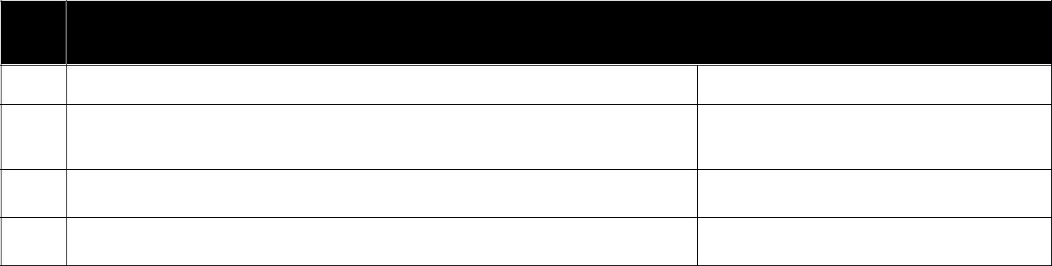

- Computation of net turnover of sales relating to on-going leasing contracts liable to tax under Section 96(10(f) of the MVAT Act, 2002: (Part D)

Particulars | Amount (Rs.)

- Turnover of sales (excluding taxes) during the period [same as Box 6(d)]

- Less: Turnover of sales exempted from tax

- Balance: Net turnover of sales liable to tax (a –b)

- Computation of tax payable under the MVAT Act

 |  | Rate of Tax | Turnover of Sales liable to tax | Tax Amount
 |  |  | Rs. | Rs.
a) | 1%
b) | 1.5%
c) | 4%
d) | 5%
e) | 8%
f) | 12.5%
g) | 15%
h) | 20%
i)
j)
k)
l)
 |  | Total
10A) |  | Sales tax collected in excess of the amount tax payable

- Computation of purchases eligible for set-off

Particulars | Amount (Rs.)

- Total turnover of purchases including taxes, value of branch / consignment transfers received and job work charges

Less:

- Imports (Direct imports)

- Imports (High seas purchases)

- Inter-State purchases

- Inter-State branch / consignment transfers received

- Within the State branch / consignment transfers received

- Within the State purchases of taxable goods from un-registered dealers

- Within the State purchases of taxable goods from registered dealers not eligible for set-off

- Within the State purchases of taxable goods exempted from tax u/s 8(2), 8(3), 8(4) and 41(4)

- Within the State purchases of tax-free goods

- Other allowable deductions / reductions

- Total deductions (b+c+d+e+f+g+h+i+j+k)

- Balance: Within the State purchases of taxable goods from registered dealers eligible for set-off (a-l)

- Tax rate wise break-up of within the State purchases from registered dealers eligible for set-off as per Box 11(m) above
 | Rate of Tax | Net Turnover of Purchases | Tax
 |  | Rs. | Amount
 |  |  | Rs.
a) | 4%
b) | 12.5%
c) | 1%
d)
e)
f)
 | Total

- Computation of set-off claimed in this return

Particulars | Purchase Value | Tax Amount
 | Rs. | Rs.

- Within the State purchases of taxable goods from registered dealers eligible for set-off as per Box 12 above

- Add: Set-off on opening stock (Trading goods) as on 1st April, 2005

- Add: Set-off on opening stock (Capital goods) as on 1st April, 2005

- Total gross set-off eligible for the period of this return (a+b+c) Less:

- Reduction in the amount of set off at the rate of 4% (Schedule C, D & E) of the purchase price under rule 53(1), 53(2) and 53(3).

Reduction in the amount of set off at the rate of 1% (Schedule B Goods) of the purchase price under rule 53(3).

- Reduction in the amount of set off under Rule 53(4), 53(5), 53(6), and 53(7)

- Total reduction (e+f)

- Balance: Net set off for the period of this return (d-g)

- Add: Adjustment to set-off claimed in earlier return (Set-off short claimed)

- Less: Adjustment to set-off claimed in earlier return (Set-off excess claimed)

- Set-off available for the period of this return (h+i-j)

- Computation of Tax Payable along with return

 | Particulars |  | Amount (Rs.)
14A) | Aggregate of credit available

- Set off available as per Box 13(k)

- Excess credit brought forward from previous tax period

- Amount already paid

Challan No. ……………………….. date ……………….

- Refund adjustment order

Order No. ……………….. …………date ………………

- WCT TDS

- Total available credit (a+b+c+d+e)

14B) Sales tax payable and adjustment of CST / ET payable against available credit

- Sales tax payable as per Box 10

- Adjustment of CST payable as per return for this period

- Adjustment of ET payable under the Maharashtra Tax on Entry of Goods into Local Areas Act, 2002
- Transferred to Return in Form 224 or 225, as the case may be, for adjustment against tax payable

- Total (a+b+c+d)

- Balance: Excess credit = 14A(f) – 14B(e) [if 14A(f) is more than 14B(e)]
- Balance: Tax payable = 10B(e) – 10A(f) [if 14A(f) is less than

14B(e)]
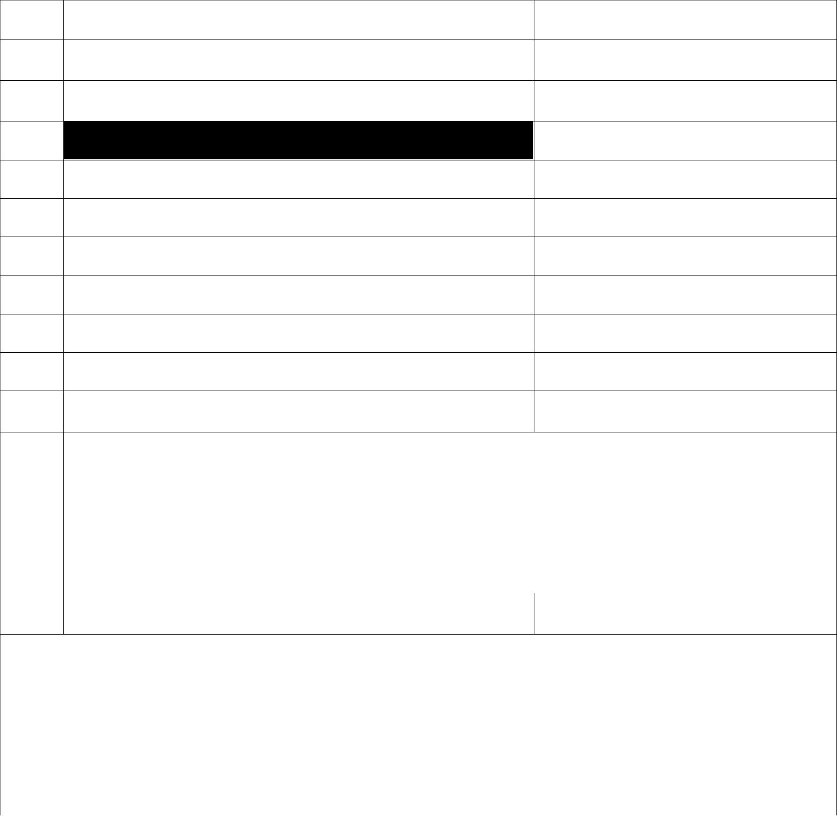
14C) Utilisation of excess credit as per Box 14B(f)

- Excess credit carried forward to subsequent tax period

- Excess credit claimed as refund in this return

14D) Tax payable with return-cum-challan
- Tax payable as per Box 14B(g)

- Add: Interest payable

- Total payable (a+b)

- Total payable transferred to Return in Form 224 or 225, as the case may be

- Amount paid along with return-cum-challan

Amount (in figures) | Rs. ……………………………..
Amount (in words) | Rupees ……………………………………………………………..
 | ………………………………………………………………………
Name of the bank and branch
on which cheque has been
drawn
- Amount paid as per Revised / Fresh return

Challan No. ……………………….. date ……………….

The statements contained in this return in Boxes 1 to 14 are true to the best of my knowledge and belief.

Date : __________________

Signature __________________

Name ______________________

Place : _________________
Designation ________________

For Treasury use only

Amount received (in figures): Rs. …………………………………

Amount received (in words): Rupees …………………………………………………………………….

………………………………………………………………………………………………………………

Date of entry :

Challan No. :

Treasury Accountant / Treasury Officer/
Agent or Manager | Space for stamp

Part II

Form No 223

(See Rule 17,18 and 45)
Challan for Treasury

Return-cum-challan of tax payable by a dealer under the M.V.A.T. Act, 2002

040-Sales Tax Receipts under the M.V.A.T. Act, 2002 – Tax collection

Please tick whichever is applicable

 |  | Periodicity of return |  |  |  |  | Monthly |  |  | Quarterly |  |  |  |  | Six-monthly
 |  | MVAT R.C. No.
 |  | CST R.C. No.
 |  | Type of return |  |  |  |  | Original |  |  |  | Fresh |  |  |  |  | Revised
 |  | Period covered by the |  |  |  |  | return
 |  |  |  | From |  |  |  |  |  |  |  |  |  | To
 |  | Date |  | Month |  |  | Year |  |  | Date |  |  | Month |  |  |  | Year
 |  | Name and address of the dealer
 |  | Name
 |  | Address

PIN Code

Tax |  | Rs. ………………………….
Interest |  | Rs ………………………….
Total (in figures) |  | Rs. …………………………
Total (in words) |  | Rupees ……………………………….
 |  | ………………………………………..
 |  | ………………………………………..
 |  | ………………………………………..
Date
Place
 |  | Signature of the depositor
 |  | For Treasury use only
Amount received
(in figures) |  | Rs. ………………………………….
Amount received
(in words) |  | Rupees ………………………………..
 |  | …………………………………………
 |  | ………………………………………….
 |  | ………………………………………….
Date of entry
Challan No.
Treasury
Accountant /
Treasury officer
Agent / Manager |  | Space for stamp

Part III

Form No 223

(See Rule 17,18 and 45)
Challan for Tax Payer

Return-cum-challan of tax payable by a dealer under the M.V.A.T. Act, 2002

040-Sales Tax Receipts under the M.V.A.T. Act, 2002 – Tax collection

Please tick whichever is applicable

 |  | Periodicity of return |  |  |  |  | Monthly |  |  | Quarterly |  |  |  |  | Six-monthly
 |  | MVAT R.C. No.
 |  | CST R.c. No.
 |  | Type of return |  |  |  |  | Original |  |  |  | Fresh |  |  |  |  | Revised
 |  | Period covered by the |  |  |  |  | return
 |  |  |  | From |  |  |  |  |  |  |  |  |  | To
 |  | Date |  | Month |  |  | Year |  |  | Date |  |  | Month |  |  |  | Year
 |  | Name and address of the dealer
 |  | Name
 |  | Address

PIN Code

Tax

Rs. ………………………….

Interest

Rs ………………………….

Total (in figures)

Rs. …………………………

Total (in words)

Rupees ……………………………….
………………………………………..
………………………………………..

………………………………………..

Date

Place

Signature of the depositor

For Treasury use only

Amount received
(in figures) | Rs. ………………………………….
Amount received
(in words) | Rupees ………………………………..
 | …………………………………………
 | ………………………………………….
 | ………………………………………….
Date of entry
Challan No.
Treasury
Accountant /
Treasury officer
Agent / Manager | Space for stamp

